CSE520
Samuel Marrujo
Professor Yu
Lab 04

Draw a rotating tetrahedron with Android

In this lab, we are to take the tetrahedron and rotate it using the Android libraries and using the Eclipse IDE. I have successfully completed this task, and here is a picture of the following:

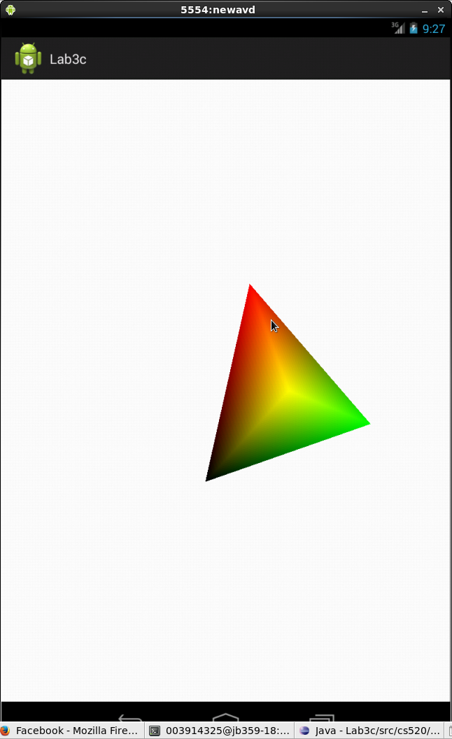
Main Activity Code:

package cs520.lab3c;

import javax.microedition.khronos.egl.EGLConfig;
import javax.microedition.khronos.opengles.GL10;

import android.app.Activity;
import android.content.Context;
import android.opengl.GLSurfaceView;
import android.opengl.GLSurfaceView.Renderer;
import android.os.Bundle;
import android.view.MotionEvent;

/**
* Wrapper activity demonstrating the use of {@link GLSurfaceView}, a view
* that uses OpenGL drawing into a dedicated surface.
*
* Shows:
* + How to redraw in response to user input.
*/
public class MainActivity extends Activity {
@Override
protected void onCreate(Bundle savedInstanceState) {
super.onCreate(savedInstanceState);

// Create our Preview view and set it as the content of our
// Activity
mGLSurfaceView = new TouchSurfaceView(this);
setContentView(mGLSurfaceView);
mGLSurfaceView.requestFocus();
mGLSurfaceView.setFocusableInTouchMode(true);

/*
mGLSurfaceView = new GLSurfaceView(this);
CubeRenderer1 renderer = new CubeRenderer1();
mGLSurfaceView.setRenderer(renderer);
setContentView(mGLSurfaceView);
*/
}

@Override
protected void onResume() {
// Ideally a game should implement onResume() and onPause()
// to take appropriate action when the activity looses focus
super.onResume();
mGLSurfaceView.onResume();
}

@Override
protected void onPause() {
// Ideally a game should implement onResume() and onPause()
// to take appropriate action when the activity looses focus
super.onPause();
mGLSurfaceView.onPause();
}

private GLSurfaceView mGLSurfaceView;
}

/**
* Implement a simple rotation control.
*
*/
class TouchSurfaceView extends GLSurfaceView {

public TouchSurfaceView(Context context) {
super(context);
mRenderer = new CubeRenderer();
setRenderer(mRenderer);
//RENDERMODE_WHEN_DIRTY means "do not call onDrawFrame() unless
// something explicitly requests rendering with requestRender()
setRenderMode(GLSurfaceView.RENDERMODE_WHEN_DIRTY);
}

@Override public boolean onTrackballEvent(MotionEvent e) {
mRenderer.mAngleX += e.getX() * TRACKBALL_SCALE_FACTOR;
mRenderer.mAngleY += e.getY() * TRACKBALL_SCALE_FACTOR;
requestRender();
return true;
}

@Override public boolean onTouchEvent(MotionEvent e) {
float x = e.getX();
float y = e.getY();
switch (e.getAction()) {
case MotionEvent.ACTION_MOVE:
float dx = x - mPreviousX;
float dy = y - mPreviousY;
mRenderer.mAngleX += dx * TOUCH_SCALE_FACTOR;
mRenderer.mAngleY += dy * TOUCH_SCALE_FACTOR;
requestRender();
}
mPreviousX = x;
mPreviousY = y;
return true;
}

/**
* Render a cube.
*/
private class CubeRenderer implements GLSurfaceView.Renderer {
public CubeRenderer() {
mCube = new Cube();
mTetrahedron = new Tetrahedron();
}

public void onDrawFrame(GL10 gl) {
/*
* Usually, the first thing one might want to do is to clear
* the screen. The most efficient way of doing this is to use
* glClear().
*/

gl.glClear(GL10.GL_COLOR_BUFFER_BIT | GL10.GL_DEPTH_BUFFER_BIT);

/*
* Now we're ready to draw some 3D objects
*/

gl.glMatrixMode(GL10.GL_MODELVIEW);
gl.glLoadIdentity();
gl.glTranslatef(0, 0, -3.0f);
gl.glRotatef(mAngleX, 0, 1, 0);
gl.glRotatef(mAngleY, 1, 0, 0);

gl.glEnableClientState(GL10.GL_VERTEX_ARRAY);
gl.glEnableClientState(GL10.GL_COLOR_ARRAY);
//mCube.draw(gl);
mTetrahedron.draw(gl);
/*
mAngleX += 1.0f; //Added by Tong for testing
mAngleY += 2.0f;

gl.glDisableClientState(GL10.GL_VERTEX_ARRAY);
gl.glDisableClientState(GL10.GL_COLOR_ARRAY);
*/
}

public void onSurfaceChanged(GL10 gl, int width, int height) {
gl.glViewport(0, 0, width, height);

/*
* Set our projection matrix. This doesn't have to be done
* each time we draw, but usually a new projection needs to
* be set when the viewport is resized.
*/

float ratio = (float) width / height;
gl.glMatrixMode(GL10.GL_PROJECTION);
gl.glLoadIdentity();
gl.glFrustumf(-ratio, ratio, -1, 1, 1, 10);
}

public void onSurfaceCreated(GL10 gl, EGLConfig config) {
/*
* By default, OpenGL enables features that improve quality
* but reduce performance. One might want to tweak that
* especially on software renderer.
*/
gl.glDisable(GL10.GL_DITHER);

/*
* Some one-time OpenGL initialization can be made here
* probably based on features of this particular context
*/
gl.glHint(GL10.GL_PERSPECTIVE_CORRECTION_HINT,
GL10.GL_FASTEST);

gl.glClearColor(1,1,1,1);
gl.glEnable(GL10.GL_CULL_FACE);
gl.glShadeModel(GL10.GL_SMOOTH);
gl.glEnable(GL10.GL_DEPTH_TEST);
}
private Cube mCube;
private Tetrahedron mTetrahedron;
public float mAngleX;
public float mAngleY;
}

private final float TOUCH_SCALE_FACTOR = 180.0f / 320;
private final float TRACKBALL_SCALE_FACTOR = 36.0f;
private CubeRenderer mRenderer;
private float mPreviousX;
private float mPreviousY;
}

class CubeRenderer1 implements GLSurfaceView.Renderer
{
GL10 gl;
Cube cube = new Cube();
Tetrahedron tetrahedron = new Tetrahedron();
private float anglex;
private float anglez;
private final int nfaces = 12;
//@Override
//Refresh automatically
public void onDrawFrame(GL10 gl)
{
gl.glClear(GL10.GL_COLOR_BUFFER_BIT | GL10.GL_DEPTH_BUFFER_BIT);
gl.glEnableClientState(GL10.GL_VERTEX_ARRAY);
gl.glEnableClientState(GL10.GL_COLOR_ARRAY);
gl.glMatrixMode(GL10.GL_MODELVIEW);
gl.glLoadIdentity();
gl.glTranslatef(0.0f, 0.0f, -4.0f);
//gl.glTranslatef(0.0f, 0.0f, -3.0f);
gl.glRotatef( anglex, 1.0f, 0.0f, 0.0f ); // Rotate about x-axis
gl.glRotatef( anglez, 0.0f, 0.0f, 1.0f); // Rotate about z-axis
//cube.draw(gl);
tetrahedron.draw(gl);
anglex += 1.0f;
anglez += 2.0f;
gl.glDisableClientState(GL10.GL_VERTEX_ARRAY);
gl.glDisableClientState(GL10.GL_COLOR_ARRAY);
}

public void onSurfaceChanged(GL10 gl, int width, int height)
{
gl.glViewport(0, 0, width, height);
float ratio = (float) width / height;
gl.glMatrixMode(GL10.GL_PROJECTION);
gl.glLoadIdentity();
gl.glFrustumf(-ratio, ratio, -1, 1, 1, 10);
}

public void onSurfaceCreated(GL10 gl, EGLConfig config)
{
gl.glDisable(GL10.GL_DITHER);
gl.glHint(GL10.GL_PERSPECTIVE_CORRECTION_HINT, GL10.GL_FASTEST);
gl.glClearColor(1, 1, 1, 0);
gl.glEnable(GL10.GL_CULL_FACE);
gl.glShadeModel(GL10.GL_SMOOTH);
gl.glEnable(GL10.GL_DEPTH_TEST);
}

}

Renderer Code:

package cs520.lab3c;

import java.nio.ByteBuffer;
import java.nio.ByteOrder;
import java.nio.IntBuffer;

import javax.microedition.khronos.opengles.GL10;

/**
* A vertex shaded cube.
*/
class Cube
{
public Cube()
{
int one = 0x10000;
int vertices[] = {
-one, -one, -one,
one, -one, -one,
one, one, -one,
-one, one, -one,
-one, -one, one,
one, -one, one,
one, one, one,
-one, one, one,
};

int colors[] = {
0, 0, 0, one,
one, 0, 0, one,
one, one, 0, one,
0, one, 0, one,
0, 0, one, one,
one, 0, one, one,
one, one, one, one,
0, one, one, one,
};

byte indices[] = {
0, 4, 5, 0, 5, 1,
1, 5, 6, 1, 6, 2,
2, 6, 7, 2, 7, 3,
3, 7, 4, 3, 4, 0,
4, 7, 6, 4, 6, 5,
3, 0, 1, 3, 1, 2
};

// Buffers to be passed to gl*Pointer() functions
// must be direct, i.e., they must be placed on the
// native heap where the garbage collector cannot
// move them.
//
// Buffers with multi-byte datatypes (e.g., short, int, float)
// must have their byte order set to native order

ByteBuffer vbb = ByteBuffer.allocateDirect(vertices.length*4);
vbb.order(ByteOrder.nativeOrder());
mVertexBuffer = vbb.asIntBuffer();
mVertexBuffer.put(vertices);
mVertexBuffer.position(0);

ByteBuffer cbb = ByteBuffer.allocateDirect(colors.length*4);
cbb.order(ByteOrder.nativeOrder());
mColorBuffer = cbb.asIntBuffer();
mColorBuffer.put(colors);
mColorBuffer.position(0);

mIndexBuffer = ByteBuffer.allocateDirect(indices.length);
mIndexBuffer.put(indices);
mIndexBuffer.position(0);
}

public void draw(GL10 gl)
{
gl.glFrontFace(GL10.GL_CW);
gl.glVertexPointer(3, GL10.GL_FIXED, 0, mVertexBuffer);
gl.glColorPointer(4, GL10.GL_FIXED, 0, mColorBuffer);
gl.glDrawElements(GL10.GL_TRIANGLES, 36, GL10.GL_UNSIGNED_BYTE, mIndexBuffer);
}

private IntBuffer mVertexBuffer;
private IntBuffer mColorBuffer;
private ByteBuffer mIndexBuffer;
}

class Tetrahedron
{
public Tetrahedron()
{
int one = 0x10000;
int vertices[] = {
0, one, 0,
0, -one, 0,
one, 0, 0,
one, 0, -one
};

int colors[] = {
0, 0, 0, one,
one, 0, 0, one,
one, one, 0, one,
0, one, 0, one,
};

byte indices[] = {
1, 3, 2,
0, 1, 2,
0, 2, 3,
0, 3, 1
};

// Buffers to be passed to gl*Pointer() functions
// must be direct, i.e., they must be placed on the
// native heap where the garbage collector cannot
// move them.
//
// Buffers with multi-byte datatypes (e.g., short, int, float)
// must have their byte order set to native order

ByteBuffer vbb = ByteBuffer.allocateDirect(vertices.length*4);
vbb.order(ByteOrder.nativeOrder());
mVertexBuffer = vbb.asIntBuffer();
mVertexBuffer.put(vertices);
mVertexBuffer.position(0);

ByteBuffer cbb = ByteBuffer.allocateDirect(colors.length*4);
cbb.order(ByteOrder.nativeOrder());
mColorBuffer = cbb.asIntBuffer();
mColorBuffer.put(colors);
mColorBuffer.position(0);

mIndexBuffer = ByteBuffer.allocateDirect(indices.length);
mIndexBuffer.put(indices);
mIndexBuffer.position(0);
}

public void draw(GL10 gl)
{
gl.glFrontFace(GL10.GL_CW);
gl.glVertexPointer(3, GL10.GL_FIXED, 0, mVertexBuffer);
gl.glColorPointer(4, GL10.GL_FIXED, 0, mColorBuffer);
gl.glDrawElements(GL10.GL_TRIANGLES, 12, GL10.GL_UNSIGNED_BYTE, mIndexBuffer);
}

private IntBuffer mVertexBuffer;
private IntBuffer mColorBuffer;
private ByteBuffer mIndexBuffer;

}

